The Thunderstorm

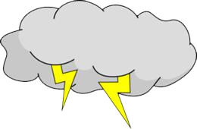The kids were outside playing catch. They heard a rumble in the sky. The didn’t want to stop playing, but they knew it wasn’t safe to be out in a storm. Also, the did not want to get wet.

They decided to go inside and play a board game. The loved listening to the thunder as the played their game. The kids went outside again after the storm had passed. They saw a rainbow!